Technical Design Document

Team Number 17

Members: Kennard Kee Wei Sheng (130214X)

Lim Wei Xiang (132752F)

Lim Yong Jie, Ryan (133096A)

Game Title: Therapist Simulator 2015

Date: 18/8/14

1. Project Executive Summary
2. Feature List

1) Sprites and animation (Ryan)

8) Sound (most likely irrklang) (Ryan)

9) User interface programming (Ryan)

3) Level transition (WX)

4) Items/Inventory (WX)

5) Experience system (Stats) (WX)

6) Enemy A.I (Ken)

2) Skills (Ken)

7) Game Physics (primarily collision detection) (Ken)

1. Software Architecture:
2. Class Diagram

See appendix A

1. Class Specification
2. Technical Challenges and Solutions
3. Conclusion

Appendix A

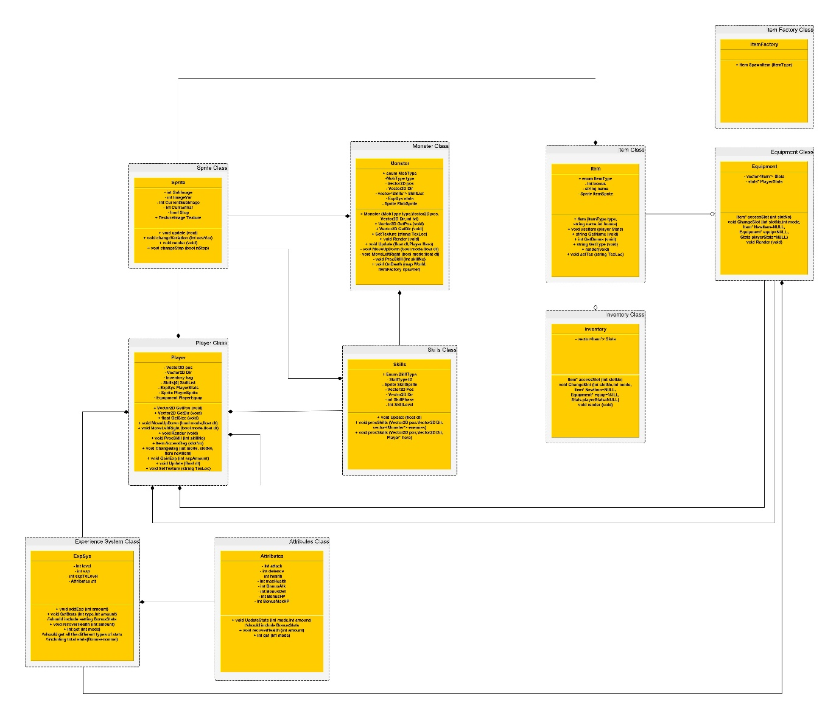-Class diagram (larger version will be included in the zip)